Module 5: Managing storage

Lab: Managing storage

**Scenario**

You have bought several hard disk drives and SSDs, and your task is to create a storage solution that can fully utilize these new devices. You decide to implement a storage solution based on the Storage Spaces feature. But first, you must install an SSD in a user's device so they can store large video files.

Objectives

After completing this lab, you will be able to:

* Create a simple volume and extend it.
* Create a storage space.

Exercise 1: Managing a simple volume

**Scenario**

You want to add one of the new disks to a user's computer so they can use the hard disk to store their video production files.

The main task for this exercise is as follows:

1. Use Disk Management to initialize a disk.
2. Create a simple volume.
3. Extend the simple volume.

Task 1: Use Disk Management to initialize a disk

1. Switch to [**LON-CL2**](urn:gd:lg:a:select-vm) using the Virtual Machine drop down menu on the Home tab of the lab environemnt.
2. Click the [**CTRL+ALT+DEL**](urn:gd:lg:a:send-vm-key-combo) button on the home tab of the lab envirionment and login as [**ADATUM\AdatumAdmin**](urn:gd:lg:a:send-vm-keys) with the password [**Pa55w.rd**](urn:gd:lg:a:send-vm-keys)
3. On **LON-CL2**, right-click **Start** and then click **Disk Management**.

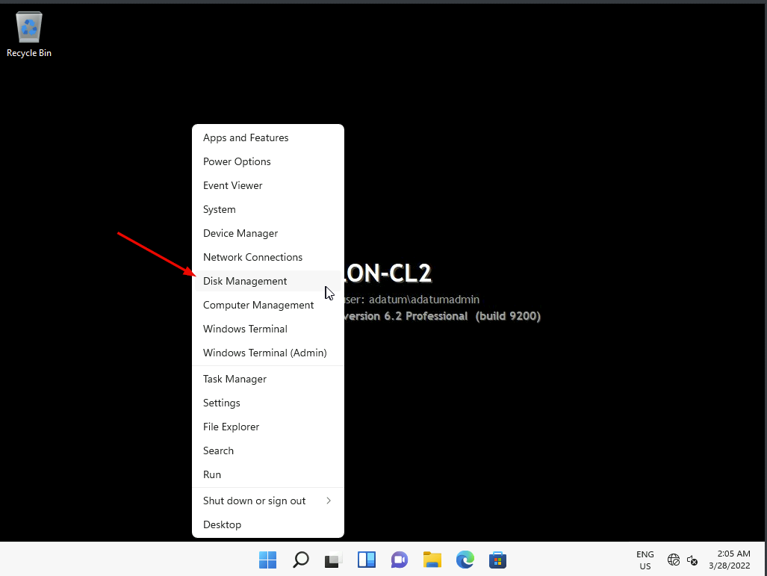

1. In the **Initialize Disk** window, clear the **Disk 2** and **Disk 3** check boxes, and then click **OK**. You can see that Disk 1 now has a status of Online.

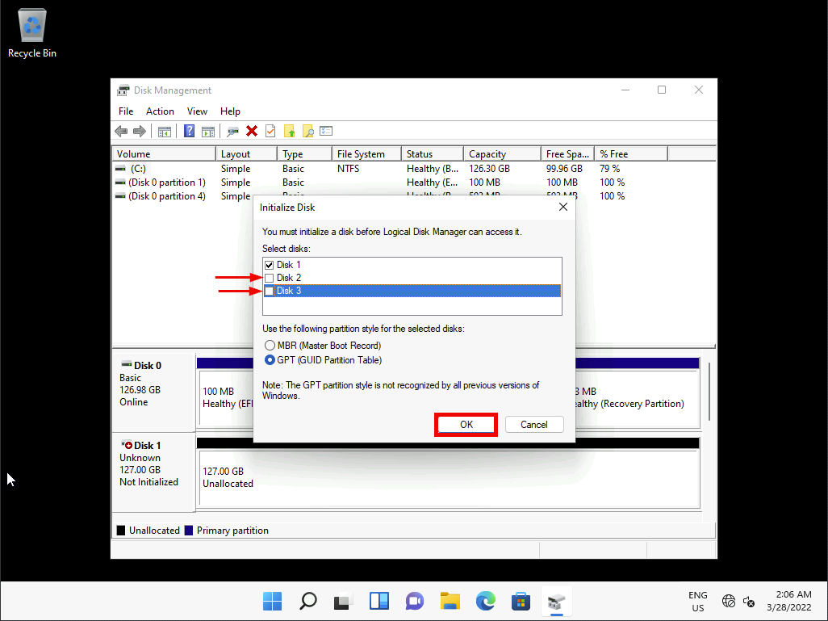

Task 2: Create a simple volume

1. Right-click the right side of **Disk 1**, and then click **New Simple Volume**.

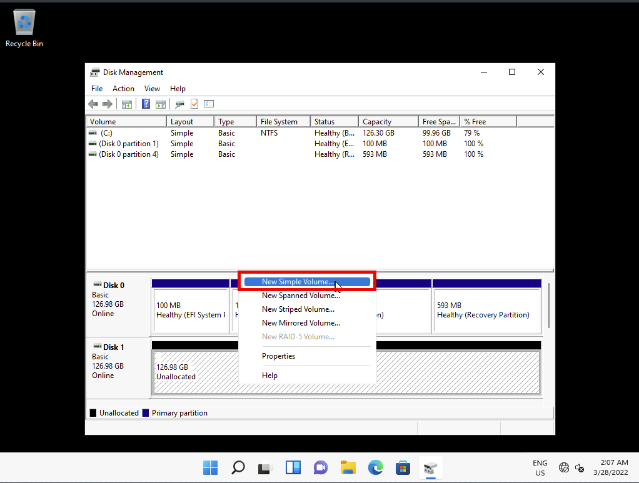

1. In the **New Simple Volume Wizard** window, click **Next**.

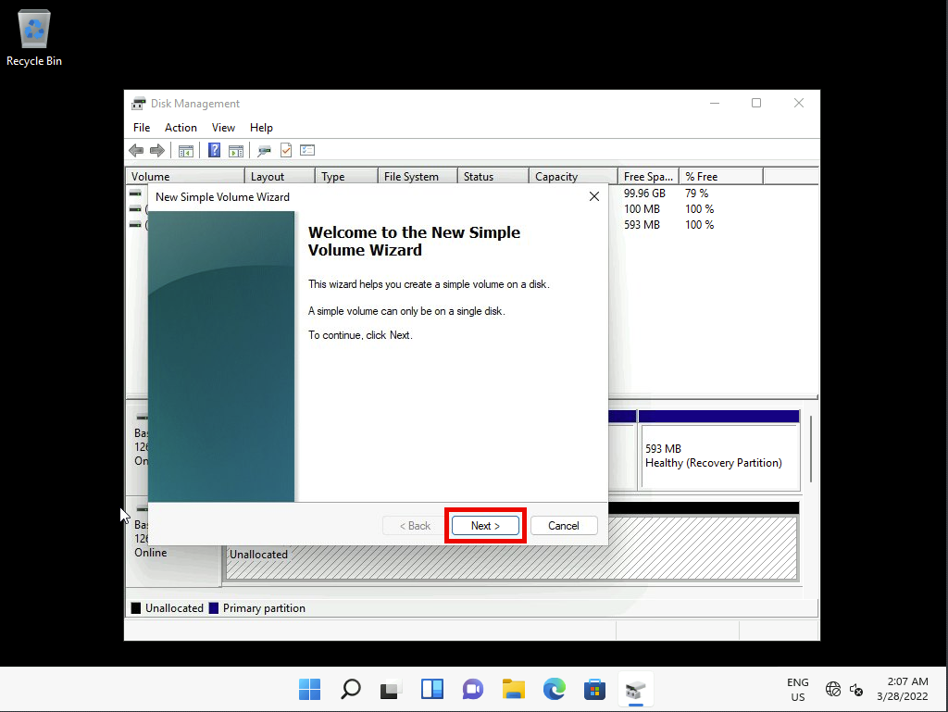

1. On the **Specify Volume Size** page, type [**5120**](urn:gd:lg:a:send-vm-keys), and then click **Next**.

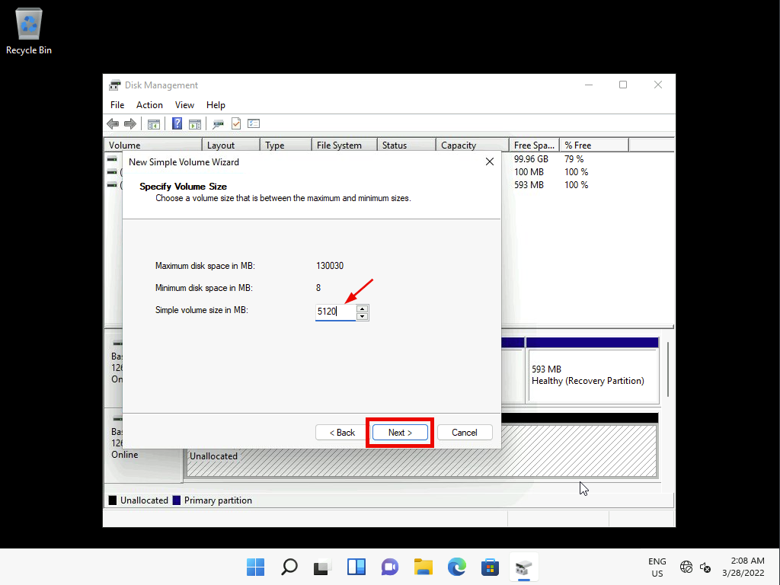

1. On the **Assign Drive Letter or Path** page, make sure that drive **E** is selected, and then click **Next**.

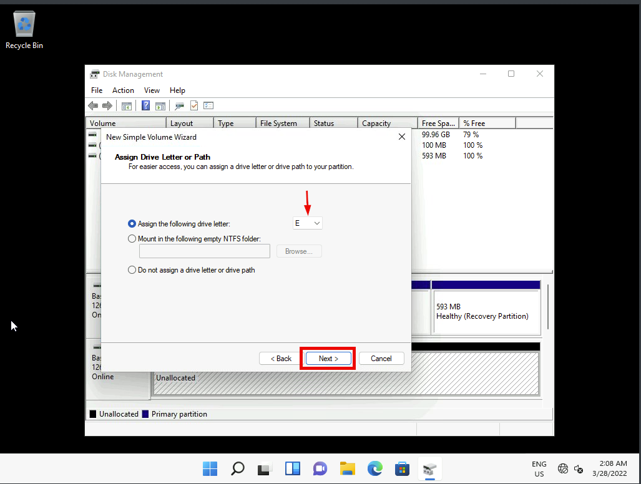

1. On the **Format partition** page, in the **Volume label** text box, type [**Videos**](urn:gd:lg:a:send-vm-keys), and then click **Next**.

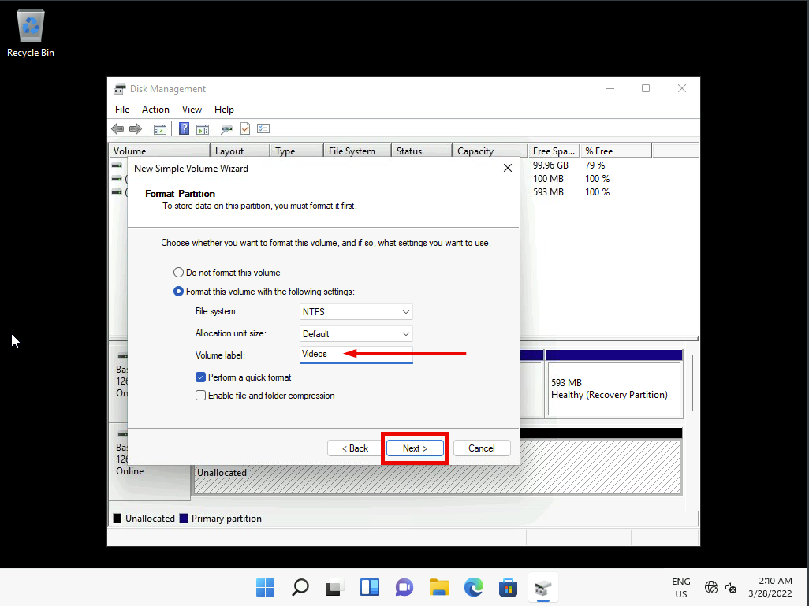

1. On the **Completing the New Simple Volume Wizard** page, click **Finish**. If you receive the error message **Location is not available**, then click **OK**.
2. If prompted whether to format drive E:, click **Cancel**.

Task 3: Extend the simple volume

1. Right-click **Start**, and then click **Windows Terminal (Admin)**.

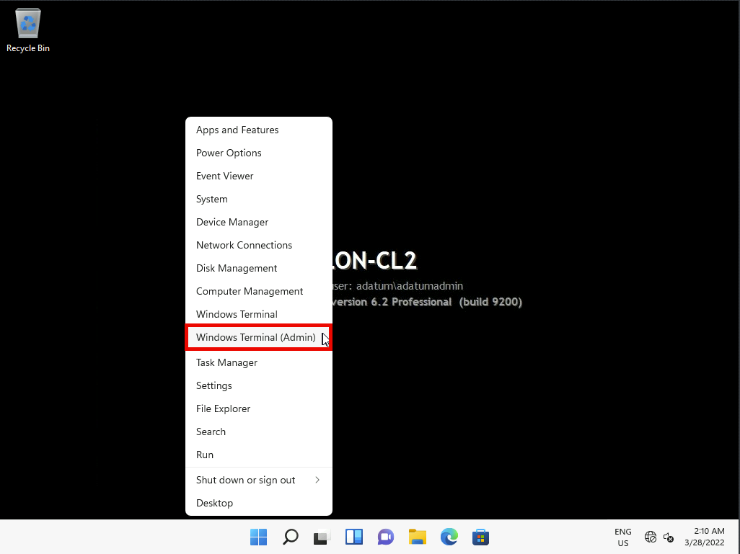

1. At the **User Account Control** prompt, click **Yes**.

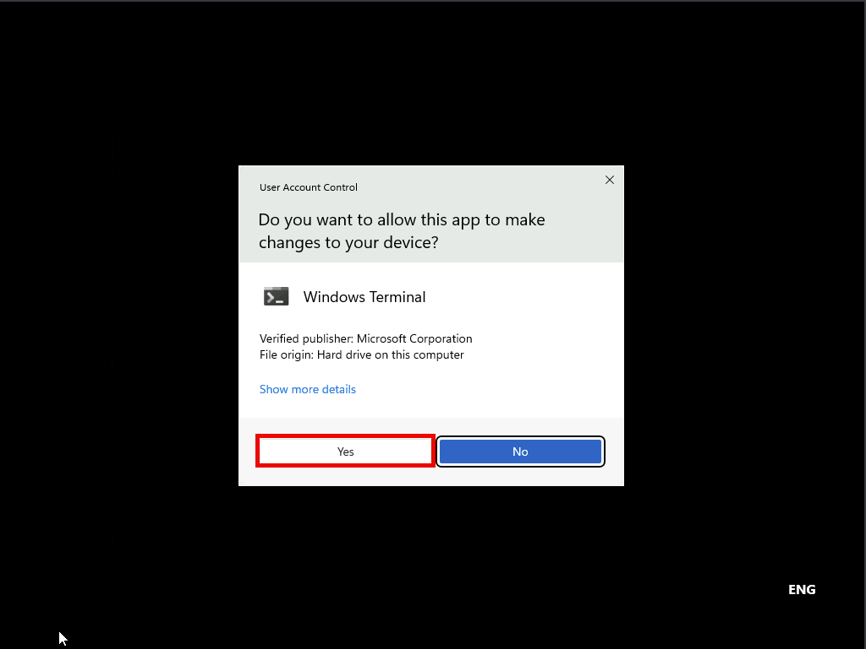

1. In Windows PowerShell (Admin), type the following two commands and after each command press Enter:
2. $MaxSize = (Get-PartitionSupportedSize -DriveLetter e).sizeMax
3. Resize-Partition -DriveLetter e -Size $MaxSize

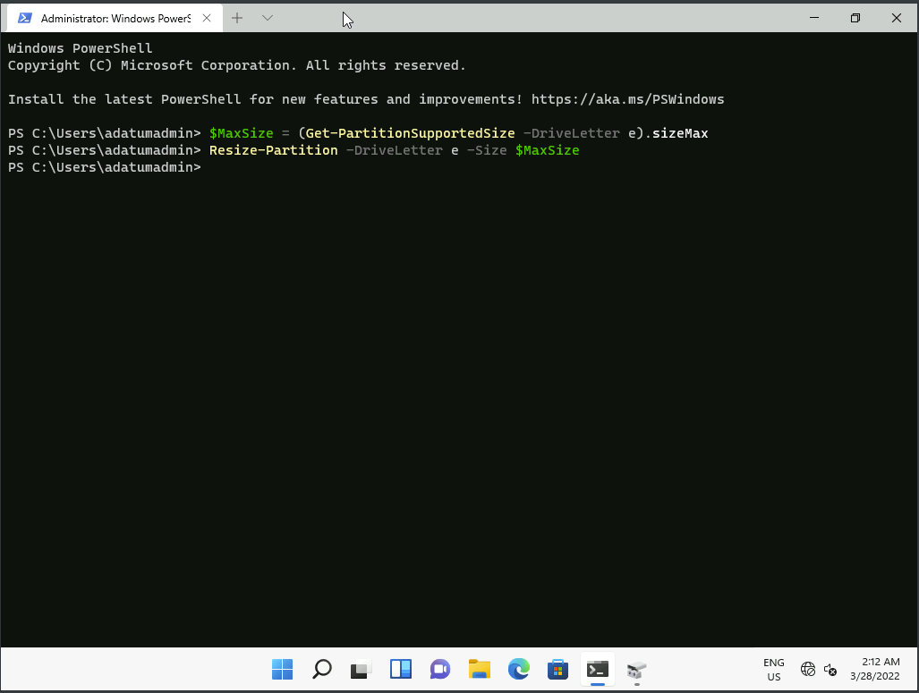

1. Switch to the **Disk Management** window, and then verify that the E volume now occupies the entire Disk 1. If the change is not visible, press F5 to refresh the view in Disk Management.

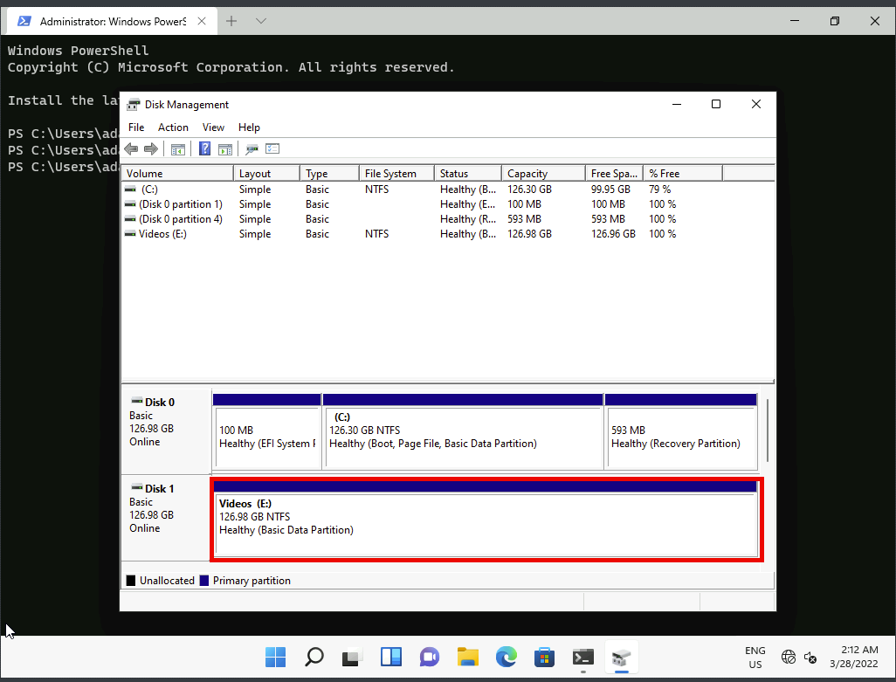

**Results**: After completing this exercise, you will have created a simple volume and then extended the volume.

Exercise 2: Creating a storage space

Task 1: Initialize the required disks

1. Switch to **Windows PowerShell**.
2. Type the following two commands and after each command press **Enter**:
3. Clear-Disk -Number 1 -RemoveData

(Press **Y** and then press **Enter** to confirm that you want to delete all partitions from disk 1 **.** )

Get-Disk | Where partitionstyle -eq 'raw' | Initialize-Disk -PartitionStyle MBR

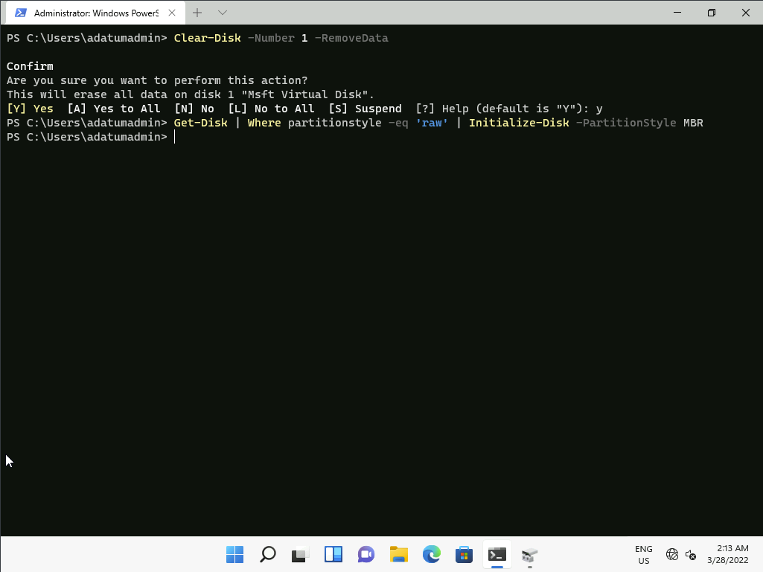

Task 2: Create a mirrored storage pool

1. Click **Start**, and then type [**Storage spaces**](urn:gd:lg:a:send-vm-keys). Press Enter.

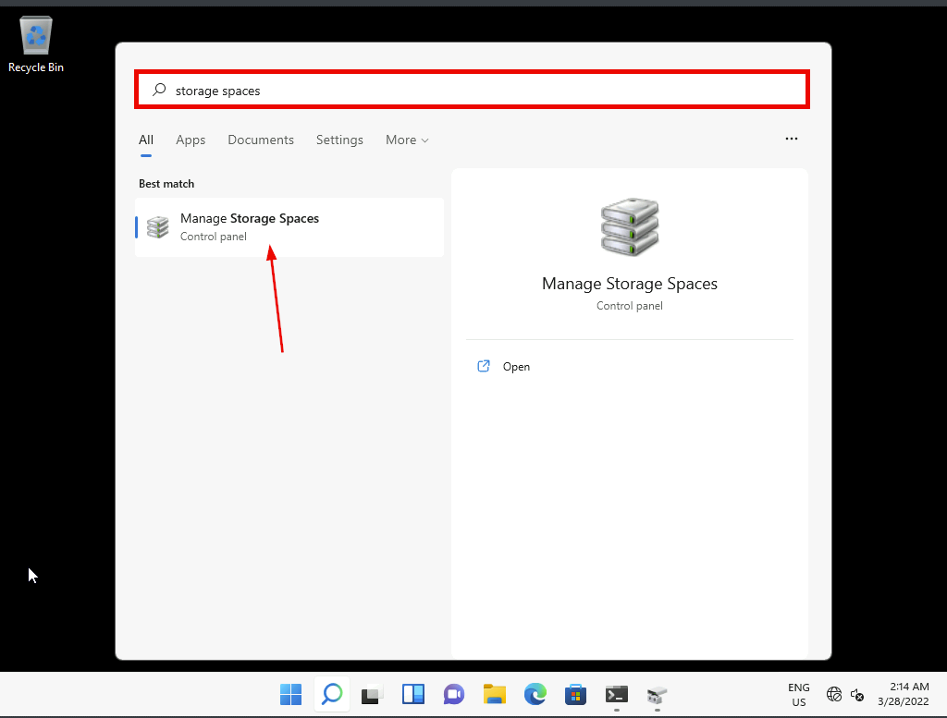

1. Click **Create a new pool and storage space**.

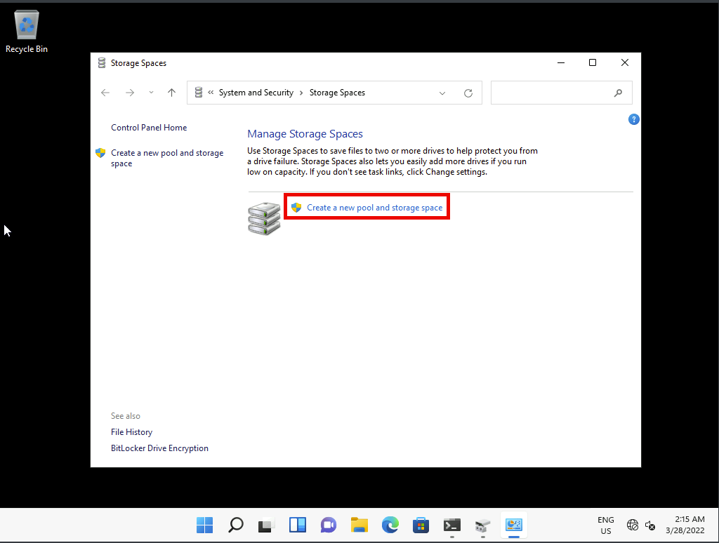

1. At the **User Account Control** prompt, click **Yes**.

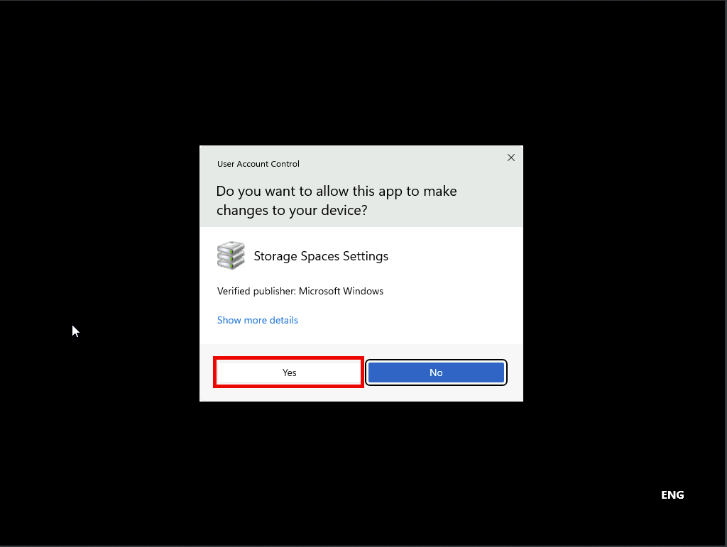

1. Notice that Disk 1, Disk 2, and Disk 3 are selected. Click **Create pool**.

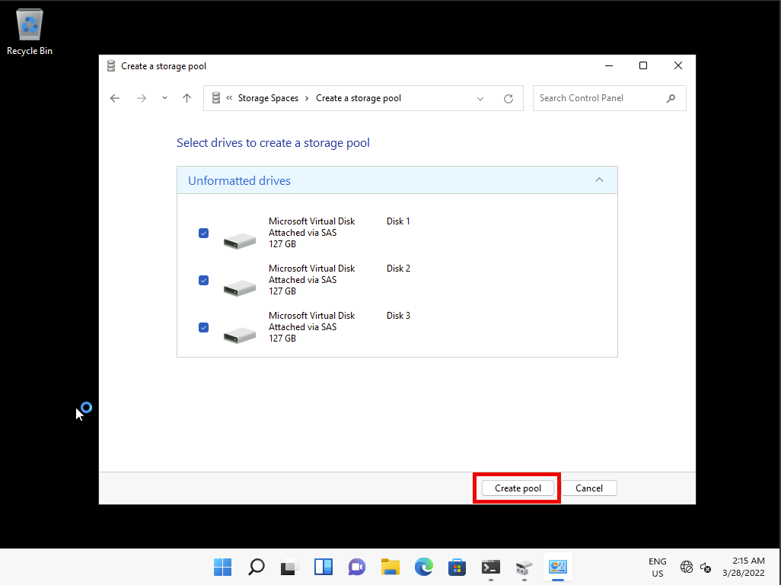

1. Notice that a resilience type of **Two-way mirror** is selected. Click **Create storage space**.

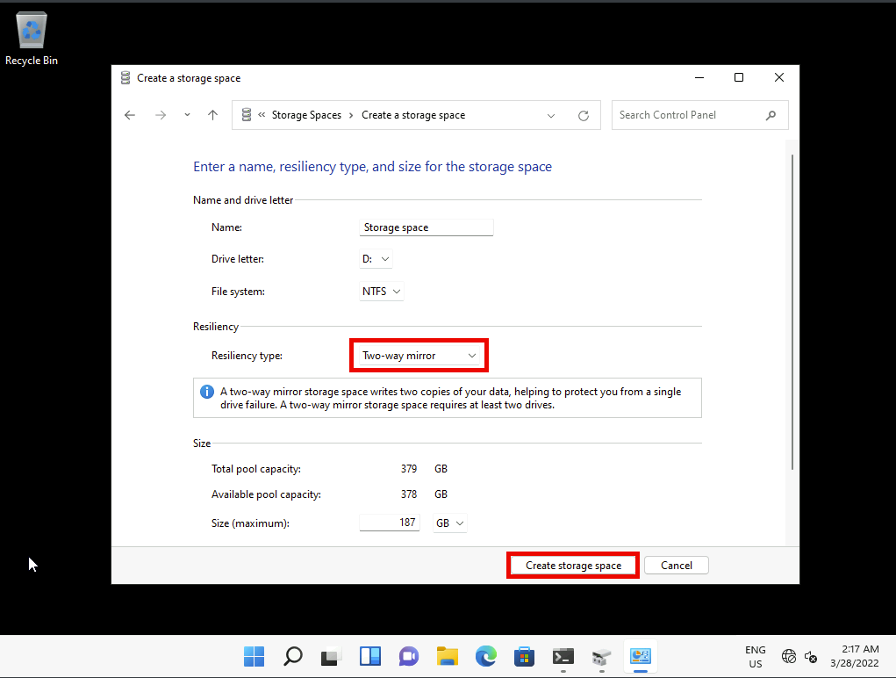

Task 3: Verify that the volume is available in File Explorer

1. Open File Explorer, and then locate and right-click **Storage Space (D:)**, and then click **Properties**.

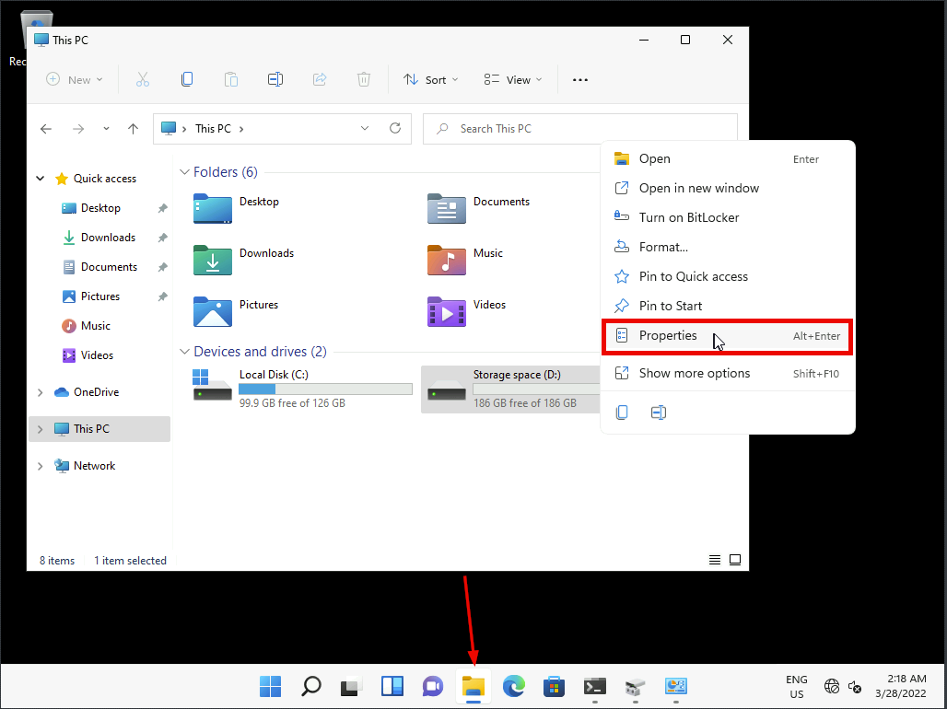

**Note:** Your drive letter may differ.

1. Notice that the capacity is 186 GB. Click **OK**.

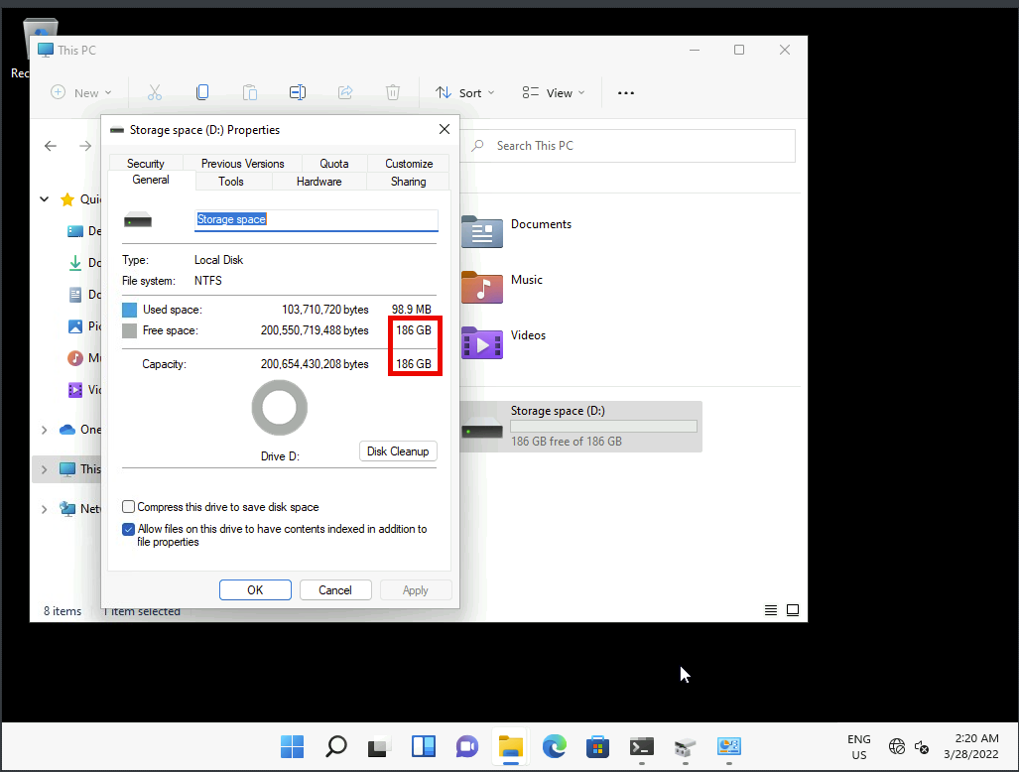

1. Switch to **Disk Management**.
2. Notice the three disks are identified as a single physical disk, Disk 4. Also notice that Disk 4 contains a simple volume of 186 GB. These representations are because the storage is managed by the Storage Spaces feature.

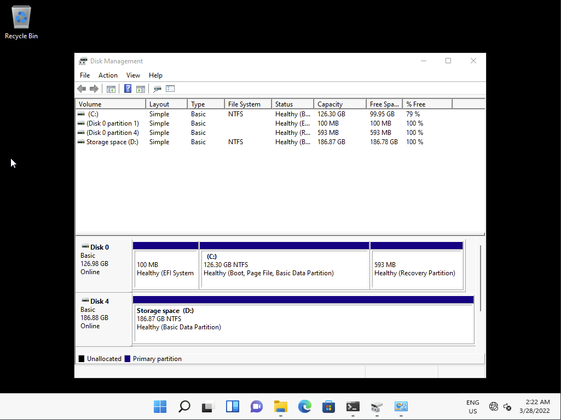

**Results**: After completing this exercise, you will have created a two-way mirror storage space.

**Congratulations!** You have now completed this lab. To continue to the next lab click End Lab in the Tools Menu . If you wish to contiue with this lab at a later date ensure you save the lab environment rather than ending it.